*Independent University Bangladesh (IUB)* **Course ID: CSE316L  
Semester:  Summer 2021  
Section: 04  
  
  
Submitted To:  
Instructor:** **Dr. Mst. Najnin  
  
Submitted By:  
Name: Md. Ashikur Rahman  
ID: 1831110  
  
Lab Report 3**

**Working Date:  14th August 2021  
                                      Submission Date: 15th August 2021**

**EXPERIMENT** **04:** Initial Router Configurations

## Objective:

1. Enable port security in switch port interface.

## Tools and Materials:

**In a real-life Scenario:**

Workstation with terminal Program (such as putty), Cisco router, rollover cable, cross-over RJ45 cable

## For Lab Purpose:

Cisco Packet Tracer Software

# Configure hostname on routers:

### Router 1

Router>en Router#config terminal

Enter configuration commands, one per line. End with CNTL/Z. Router(config)#hostname RouterA

RouterA(config)#hostname Rounter1 Rounter1(config)#interface fa 0/0

Rounter1(config-if)#ip address 192.168.1.2 255.255.255.0 Rounter1(config-if)#no shutdown

Rounter1(config-if)#

%LINK-5-CHANGED: Interface FastEthernet0/0, changed state to up

%LINEPROTO-5-UPDOWN: Line protocol on Interface FastEthernet0/0, changed state to up

Rounter1(config-if)#end Rounter1#

%SYS-5-CONFIG_I: Configured from console by console Rounter1#

### Router 2

Router>en Router#config t

Enter configuration commands, one per line. End with CNTL/Z. Router(config)#hostname Router2

Router2(config)#interface fa 0/0 Router2(config-if)#192.168.1.2 255.255.255.0

^

% Invalid input detected at '^' marker.

Router2(config-if)#ip address 192.168.1.2 255.255.255.0 Router2(config-if)#no shut

Router2(config-if)#

%LINK-5-CHANGED: Interface FastEthernet0/0, changed state to up

%LINEPROTO-5-UPDOWN: Line protocol on Interface FastEthernet0/0, changed state to up Router2(config-if)#end

Router2#

%SYS-5-CONFIG_I: Configured from console by console Router2#

**Ping Router 2 from Router 1**

Rounter1#ping 192.168.1.2 Type escape sequence to abort.

Sending 5, 100-byte ICMP Echos to 192.168.1.2, timeout is 2 seconds:

!!!!!

Success rate is 100 percent (5/5), round-trip min/avg/max = 5/6/8 ms Rounter1#

# To configure both the routers to connect to VLAN 2 on the

**switch**

## Creating Vlan on the Switch:

Switch>en Switch#config t

Enter configuration commands, one per line. End with CNTL/Z. Switch(config)#vlan 2

Switch(config-vlan)#name Cisco Switch(config-vlan)#end Switch#

%SYS-5-CONFIG_I: Configured from console by console

## To configure the interfaces on the switch to use VLAN 2, use the following commands:

Switch#config t

Enter configuration commands, one per line. End with CNTL/Z. Switch(config)#interface fa 0/1

Switch(config-if)#description ToRouter1 Switch(config-if)#switchport mode access Switch(config-if)#switchport access vlan 2 Switch(config-if)#end

Switch#

%SYS-5-CONFIG_I: Configured from console by console Switch#

## g Router 1 from Router 2

Router2>enable Router2#ping 192.168.1.1

Type escape sequence to abort. Sending 5, 100-byte ICMP Echos to 192.168.1.1, timeout is 2 seconds:

.....

Success rate is 0 percent (0/5) Router2#

# Ethernet interface connecting to router B into VLAN 2.

Switch#config t

Enter configuration commands, one per line. End with CNTL/Z. Switch(config)#int fa 0/1

Switch(config-if)#description TORouter2 Switch(config-if)#switchport mode access Switch(config-if)#switchport access vlan 2 Switch(config-if)#end

Switch#

### Ping from Router 1

Router1#ping 192.168.1.2

Type escape sequence to abort.

Sending 5, 100-byte ICMP Echos to 192.168.1.2, timeout is 2 seconds:

.....

Success rate is 0 percent (0/5) Router1#

7.Reload the Switch:

Switch>enable Switch#erase ?

startup-config Erase contents of configuration memory Switch#erase startup-config

Erasing the nvram filesystem will remove all configuration files! Continue? [confirm]

[OK]

Erase of nvram: complete

%SYS-7-NV_BLOCK_INIT: Initialized the geometry of nvram Switch#reload

Proceed with reload? [confirm]

C2950 Boot Loader (C2950-HBOOT-M) Version 12.1(11r)EA1, RELEASE SOFTWARE (fc1)

Compiled Mon 22-Jul-02 18:57 by miwang

Cisco WS-C2950-24 (RC32300) processor (revision C0) with 21039K bytes of memory.

2950-24 starting...

Base ethernet MAC Address: 0001.96E2.ED42 Xmodem file system is available.

Initializing Flash...

flashfs[0]: 2 files, 0 directories

flashfs[0]: 0 orphaned files, 0 orphaned directories flashfs[0]: Total bytes: 64016384

flashfs[0]: Bytes used: 3058664 flashfs[0]: Bytes available: 60957720 flashfs[0]: flashfs fsck took 1 seconds.

...done Initializing Flash.

Boot Sector Filesystem (bs:) installed, fsid: 3 Parameter Block Filesystem (pb:) installed, fsid: 4

Show VLAN info: Switch>enable Switch#show vlan

VLAN Name Status Ports

1. default active Fa0/1, Fa0/2, Fa0/3, Fa0/4 Fa0/5, Fa0/6, Fa0/7, Fa0/8

Fa0/9, Fa0/10, Fa0/11, Fa0/12 Fa0/13, Fa0/14, Fa0/15, Fa0/16 Fa0/17, Fa0/18, Fa0/19, Fa0/20 Fa0/21, Fa0/22, Fa0/23, Fa0/24

1. Cisco active

1002 fddi-default act/unsup

1003 token-ring-default act/unsup

1004 fddinet-default act/unsup

1005 trnet-default act/unsup

VLAN Type SAID MTU Parent RingNo BridgeNo Stp BrdgMode Trans1 Trans2

1 enet 100001 1500 0 0

2 enet 100002 1500 0 0

1002 fddi 101002 1500 0 0

1003 tr 101003 1500 0 0

1004 fdnet 101004 1500 - - - ieee - 0 0

1005 trnet 101005 1500 - - - ibm - 0 0

Remote SPAN VLANs

Primary Secondary Type Ports

Switch#write Building configuration... [OK]

Switch#reload Proceed with reload? [confirm]

C2950 Boot Loader (C2950-HBOOT-M) Version 12.1(11r)EA1, RELEASE SOFTWARE (fc1)

Compiled Mon 22-Jul-02 18:57 by miwang

Cisco WS-C2950-24 (RC32300) processor (revision C0) with 21039K bytes of memory.

2950-24 starting...

Base ethernet MAC Address: 0001.96E2.ED42 Xmodem file system is available.

Initializing Flash...

flashfs[0]: 3 files, 0 directories

flashfs[0]: 0 orphaned files, 0 orphaned directories flashfs[0]: Total bytes: 64016384

flashfs[0]: Bytes used: 3059641 flashfs[0]: Bytes available: 60956743 flashfs[0]: flashfs fsck took 1 seconds.

...done Initializing Flash.

Boot Sector Filesystem (bs:) installed, fsid: 3 Parameter Block Filesystem (pb:) installed, fsid: 4

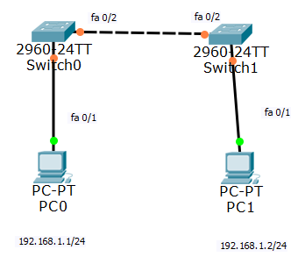

Click OK to accept the default settings and the router CLI will appear. Just hit ENTER in your keyboard and you will get to the user mode (switch & gt;).

**Configure Switch:**

From switch 1, search mac address table Switch1:

Switch>**enable**

Enters switch enable mode

# Switch>enable

Switch#sh mac address-table Mac Address Table

Vlan Mac Address Type Ports

1 0060.2f6c.e002 DYNAMIC Fa0/2

Switch#

This is mac address of switch 2. Switch 2:

# Switch>enable

Switch#sh mac address-table Mac Address Table

Vlan Mac Address Type Ports

1 000c.cf96.8802 DYNAMIC Fa0/2

Switch#

This is the mac address of switch1.

Switch sends BPDUs for searching mac address, spanning tree protocol. No PCs’ mac address

here. Even their own mac address also not here.

No traffic flow from PC through switch yet, so no aware of it.

So, ping between the PCs and check switches’ mac address table.

Step 2: ping from PCs Firstly, let set IP in PCs.

PC1 configuration

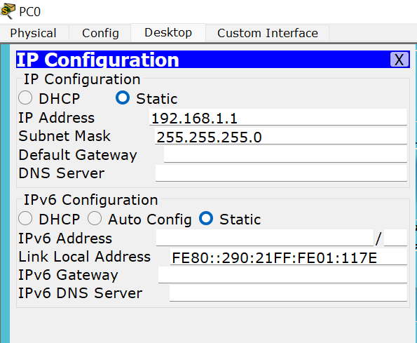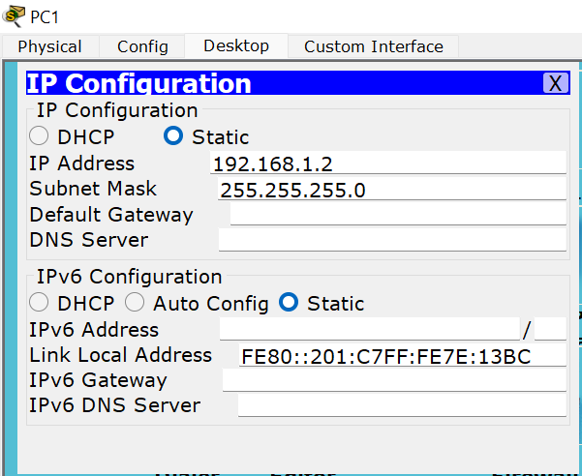

PC2 configuration

Ping from PC1:

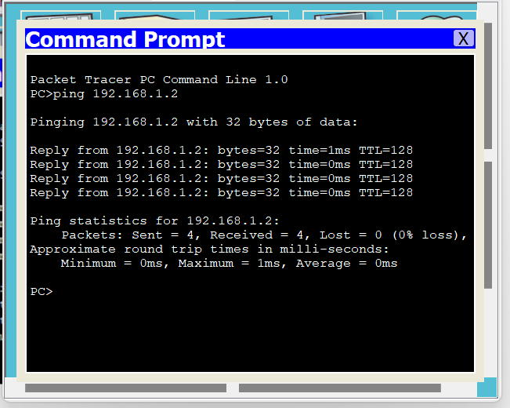

Now Switch 2:

# Switch>enable

Switch#sh mac address-table Mac Address Table

Vlan Mac Address Type Ports

1 0001.63b1.7432 DYNAMIC Fa0/2

1 0030.f28d.4321 DYNAMIC Fa0/1

1 0060.2f6c.e002 DYNAMIC Fa0/2

Switch#

1st one must be PC1’s mac address and 2nd one must be PC2’s mac address

From switch 1

# Switch>en

Switch#sh mac address-table Mac Address Table

Vlan Mac Address Type Ports

1 0001.63b1.7432 DYNAMIC Fa0/1

1 000c.cf96.8802 DYNAMIC Fa0/2

1 0030.f28d.4321 DYNAMIC Fa0/2

Switch#

1 st one PC1’s mac address and 3 rd one PC2’s mac address.

Step 3: The switches are connected with PCs through Fa 0/1 port. For configuring security switch must be in access mode, not in trunk mode or dynamic.

SW1:

# Switch#config t

Enter configuration commands, one per line. End with CNTL/Z. Switch(config)#int fa 0/1

Switch(config-if)#switchport mode access Switch(config-if)#switch port-security Switch(config-if)#

SW2:

# Switch>en Switch#config t

Enter configuration commands, one per line. End with CNTL/Z. Switch(config)#int fa 0/1

Switch(config-if)#switchport mode access Switch(config-if)#switch port-security Switch(config-if)#do sh port-security

Secure Port MaxSecureAddr CurrentAddr SecurityViolation Security Action (Count) (Count) (Count)

Fa0/1 1 1 0 Shutdown

Switch(config-if)#

Let check how many port by default allowed, default value 1. Switch(config-if)#switch port-security maximum 1 Switch(config-if)#

Switch1:

Switch(config-if)#switch port-security maximum 1 Switch(config-if)#

Step 4: What is the security action if port security violation? Three possible actions can be taken by switch,

Protect: drop traffic from unwanted mac address, doesn’t display msg on switch, doesn’t

increase violation count.

Restrict: also drop traffic from unwanted mac address and also display msg n switch, increases violation count.

Shut down: disable the port, shutting down interfaces, as well increasing violation count Default action: shut down

Switch 2:

Switch(config)#int fa 0/1

Switch(config-if)#switchport port-security violation ? protect Security violation protect mode

restrict Security violation restrict mode shutdown Security violation shutdown mode

Switch(config-if)#switchport port-security violation shutdown Switch(config-if)#

Switch 1:

Switch&gt;enable Switch#config t

Enter configuration commands, one per line. End with CNTL/Z. Switch(config)#int fa 0/1

Switch(config-if)#switchport port-security violation ? protect Security violation protect mode

restrict Security violation restrict mode shutdown Security violation shutdown mode

Switch(config-if)#switchport port-security violation

% Incomplete command.

Switch(config-if)#switchport port-security violation shutdown Switch(config-if)#

Again ping from PC1:

PC&gt;ping 192.168.1.12

Pinging 192.168.1.12 with 32 bytes of data:

Reply from 192.168.1.12: bytes=32 time=0ms TTL=128 Reply from 192.168.1.12: bytes=32 time=0ms TTL=128 Reply from 192.168.1.12: bytes=32 time=1ms TTL=128 Reply from 192.168.1.12: bytes=32 time=0ms TTL=128 **Now from Switch 1:**

# Switch#sh port-security address Secure Mac Address Table

Vlan Mac Address Type Ports Remaining Age (mins)

1 0001.C77E.13BC DynamicConfigured FastEthernet0/1 -

Total Addresses in System (excluding one mac per port) : 0

Max Addresses limit in System (excluding one mac per port) : 1024 Switch#

PC1 enlisted as a secured mac address. From switch 2:

# Switch#sh port-security address Secure Mac Address Table

Vlan Mac Address Type Ports Remaining Age (mins)

1 0001.C77E.13BC DynamicConfigured FastEthernet0/1 -

Total Addresses in System (excluding one mac per port) : 0

Max Addresses limit in System (excluding one mac per port) : 1024 Switch#

PC2 enlisted as a secure mac address in switch 2. Directly connected, not in switch 1. Switch1:

Switch&gt;en

Switch#sh running-config Building configuration...

Current configuration : 1093 bytes

!

version 12.2

no service timestamps log datetime msec

no service timestamps debug datetime msec no service password-encryption

!

hostname Switch

!

!

!

!

!

spanning-tree mode pvst

!

interface FastEthernet0/1 switchport mode access switchport port-security

!

interface FastEthernet0/2

Two commands are saved, no information regarding secure port address. Step 5: save running config and switch reload.

Switch#write

Building configuration... [OK]

Switch#reload

Proceed with reload? [confirm]yC2960 Boot Loader (C2960-HBOOT-M) Version 12.2(25r)FX, RELEASE SOFTWARE (fc4)

Cisco WS-C2960-24TT (RC32300) processor (revision C0) with 21039K bytes of memory. 2960-24TT starting...

Base ethernet MAC Address: 000C.CF4C.777A Xmodem file system is available.

Initializing Flash...

flashfs[0]: 2 files, 0 directories

flashfs[0]: 0 orphaned files, 0 orphaned directories flashfs[0]: Total bytes: 64016384

flashfs[0]: Bytes used: 4416014 flashfs[0]: Bytes available: 59600370 flashfs[0]: flashfs fsck took 1 seconds.

...done Initializing Flash.

Boot Sector Filesystem (bs:) installed, fsid: 3 Parameter Block Filesystem (pb:) installed, fsid: 4

Loading &quot;flash:/c2960-lanbase-mz.122-25.FX.bin&quot;... ########################################################################## [OK]

Switch>en

Switch#sh port-security address Secure Mac Address Table

Vlan Mac Address Type Ports Remaining Age (mins)

Total Addresses in System (excluding one mac per port) : 0

Max Addresses limit in System (excluding one mac per port) : 1024 Switch#

After switch reloading, no information here, regarding dynamically learned secure port address. Step 6: enable sticky secure mac address feature.

Switch#config t

Enter configuration commands, one per line. End with CNTL/Z. Switch(config)#int fa 0/1

Switch(config-if)#switchport port-security mac address sticky

^

% Invalid input detected at &#39;^&#39; marker. Switch(config-if)#switchport port-security mac-address sticky Switch(config-if)#

From PC1 Pinging, PC&gt;ping 192.168.1.12

Pinging 192.168.1.12 with 32 bytes of data:

Reply from 192.168.1.12: bytes=32 time=1ms TTL=128 Reply from 192.168.1.12: bytes=32 time=0ms TTL=128 Reply from 192.168.1.12: bytes=32 time=0ms TTL=128 Reply from 192.168.1.12: bytes=32 time=0ms TTL=128 Ping statistics for 192.168.1.12:

Packets: Sent = 4, Received = 4, Lost = 0 (0% loss), Approximate round trip times in milli-seconds:

Minimum = 0ms, Maximum = 1ms, Average = 0ms Check secure port address again in switch 1,

# Switch#sh port-security address Secure Mac Address Table

Vlan Mac Address Type Ports Remaining Age (mins)

1 0001.C77E.13BC SecureSticky FastEthernet0/1 -

Total Addresses in System (excluding one mac per port) : 0

Max Addresses limit in System (excluding one mac per port) : 1024 Switch#

Now check running configuration, Switch#show running-config Building configuration...

Current configuration : 1199 bytes

!

version 12.2

no service timestamps log datetime msec

no service timestamps debug datetime msec no service password-encryption

!

hostname Switch

!

!

!

!

!

spanning-tree mode pvst

!

interface FastEthernet0/1 switchport mode access switchport port-security

switchport port-security mac-address sticky

switchport port-security mac-address sticky 0001.9695.7E56

Switch#

Secure port address is saved.

Again, save running config and reload switch, Switch#write

Building configuration... [OK]

Switch#reload

Proceed with reload? [confirm]yC2960 Boot Loader (C2960-HBOOT-M) Version 12.2(25r)FX, RELEASE SOFTWARE (fc4)

Cisco WS-C2960-24TT (RC32300) processor (revision C0) with 21039K bytes of memory. 2960-24TT starting... same as previous…

# Switch#sh port-security address Secure Mac Address Table

Vlan Mac Address Type Ports Remaining Age (mins)

1 0001.C77E.13BC SecureSticky FastEthernet0/1 -

Total Addresses in System (excluding one mac per port) : 0

Max Addresses limit in System (excluding one mac per port) : 1024 Switch#

Now secure port address in the table.